Practical no.3
Q2
import java.applet.Applet;
import java.awt.*;
import java.awt.GridLayout;
import java.awt.Button;

/**
*<applet code="Grid" width =300 height=50>
* </applet>
*/
public class Grid extends Applet {

public void init() {
GridLayout g1 = new GridLayout(4,3);
setLayout( g1 );
for(int i=0;i<=9;i++)
{
add(new Button(" "+ i));
}

}
}
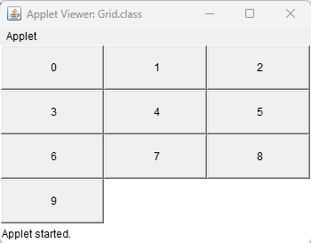

Q1. 5*5 Button
import java.applet.Applet;
import java.awt.*;
import java.awt.GridLayout;
import java.awt.Button;

/**
*<applet code="Grid" width =300 height=50>
* </applet>

*/
public class GridApplet extends Applet {

/**
* Initialization method that will be called after the applet is loaded into
* the browser.
*/
public void init() {
GridLayout g1 = new GridLayout(5,5);
setLayout( g1 );
for(int i=1;i<=25;i++)
{
Button button = new Button("Button" + (i + 1));
add(button);
}
}

// TODO overwrite start(), stop() and destroy() methods
}
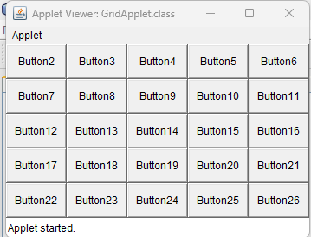

Q4.
import java.applet.Applet;
import java.awt.*;
/**
*<applet code="Grid" width =300 height=50>
* </applet>

*/
public class Border extends Applet {

/**
* Initialization method that will be called after the applet is loaded into
* the browser.
*/
public void init() {
setLayout(new BorderLayout());
add(new Button("North"),BorderLayout.NORTH);
add(new Button("South"),BorderLayout.SOUTH);
add(new Button("center"),BorderLayout.CENTER);
add(new Button("WEST"),BorderLayout.WEST);
add(new Button("EAST"),BorderLayout.EAST);

}

public Insets getInsets()
{
return new Insets(10,20,10,20);
}
}
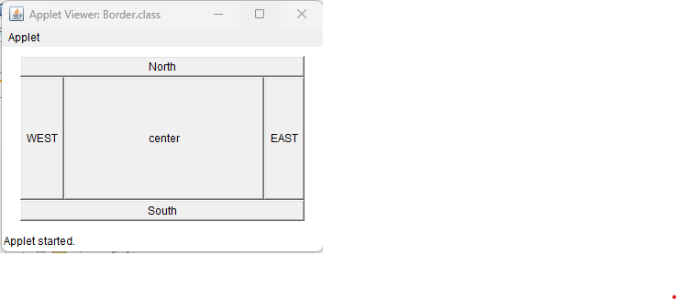

Q3.
import java.applet.Applet;
import java.awt.*;
import java.awt.Button;
import java.awt.GridLayout;

/**
*
* @author geeta
*/
public class buttonApplet extends Applet {

/**
* Initialization method that will be called after the applet is loaded into
* the browser.
*/
public void init() {
// TODO start asynchronous download of heavy resources

Button b1 = new Button("Button1");

Button b2 = new Button("Button2");
Button b3 = new Button("Button3");
Button b4 = new Button("Button4");
Button b5 = new Button("Button5");
add(b1);
add(b2);
add(b3);
add(b4);
add(b5);
}

// TODO overwrite start(), stop() and destroy() methods
}

